Virtio-IPSec Accelerator

Revision History

Date | Version | Author | Reason
04/22/2015 | 1 | Freescale Semiconductor | Initial version

Table of Contents
Table of Contents 3
1 Introduction 4
2 References 4
3 Scope 4
4 Virtio IPsec Device 5
5 Virtio IPsec Device Definition 6
5.1 Bus Details 6
5.1.1 Virtio Device ID 7
5.1.2 PCI Device Discovery 7
5.1.3 Feature Bits 7
5.1.4 Virtio IPSec Device Configuration Registers 8
5.1.5 Virtqueues 9
5.2 Device Emulation 10
5.3 Invocation of device in QEMU 11
6 API Messages between Virtio IPsec driver (Guest driver) and Vhost-User 11
6.1 Feature Bits 11
6.2 Information in queues 11
6.3 Command Message Format 11
6.4 Control Queue 13
6.4.1 GET_CAPABILITIES 13
6.4.2 SET_GUEST_ENDIAN 14
6.4.3 ADD OUT_SA 14
6.4.4 ADD_IN_SA 18
6.4.5 UPDATE SA 18
6.4.6 DELETE SA 19
6.4.7 READ OUT_SA 19
6.4.8 READ_FIRST_N_OUT_SA 19
6.4.9 READ_NEXT_N_OUT_SA 20
6.4.10 READ IN_SA 20
6.4.11 READ_FIRST_N_IN_SA 20
6.5 Notification Queue 21
6.5.1 VIRTIO_IPSEC_NOTFIY_LIFETIME_KB_EXPIRY 21
6.5.2 VIRTIO_IPSEC_NOTIFY_BEFORE_SEQNUM_OVERFLOW 22
6.5.3 VIRTIO_IPSEC_NOTIFY_SEQNUM_PERIODIC 22
6.6 Data Queue 22
7 Live Migration States 23
8 Libvirt Integration 23
9 IPsec Packet Processing – Look Aside Accelerator Packet Flow 24

Introduction
A virtio-IPSec driver and device are introduced in the Virtio Framework as per the Virtio Standards, so that the VNF can use the Virtio IPsec driver to access the IPsec Accelerator functionality. Using the standard Virtio IPSec Driver the VNF can access any underlying vendor specific IPsec Accelerator.

References
Virtio Specifications
http://docs.oasis-open.org/virtio/virtio/v1.0/virtio-v1.0.pdf
http://ozlabs.org/~rusty/virtio-spec/virtio-0.9.5.pdf
Virtio-net, Vhost-net, Vhost-user implementations in Linux 3.19, Qemu 2.2.0

Scope
This document identifies a Virtio IPsec Accelerator which will perform IPsec Record Layer Acceleration. (e.g. Freescale SEC engine). In this case, the Guest VM can push IPsec SAs into the hardware accelerator. Subsequently when buffers are submitted, the accelerator can perform Outbound SA processing (clear packet to encrypted packet) or Inbound SA processing (encrypted packet to clear packet) as required. This belongs to Look Aside class of accelerators as, the Guest VM submits packets to the accelerator and receives the processed packet from the accelerator before sending the packet out.

Virtio IPsec Device
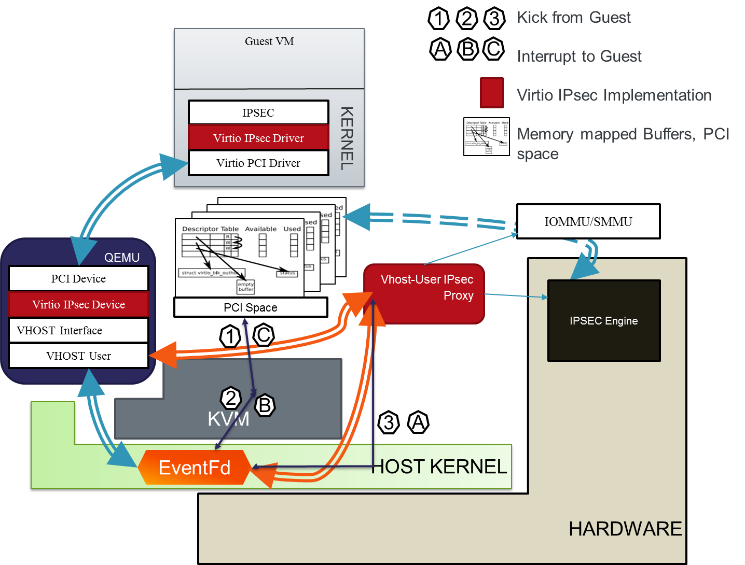
Figure 1: Virtio IPSec Device
Figure 1 shows the Virtio Device implementation in Linux. In the Guest VM, the Virtio IPsec Driver will drives the Virtio IPSec Device. The backend implementation of Virtio IPSec is a Virtio IPSec proxy, that interfaces with the IPsec Engine Hardware Accelerator.
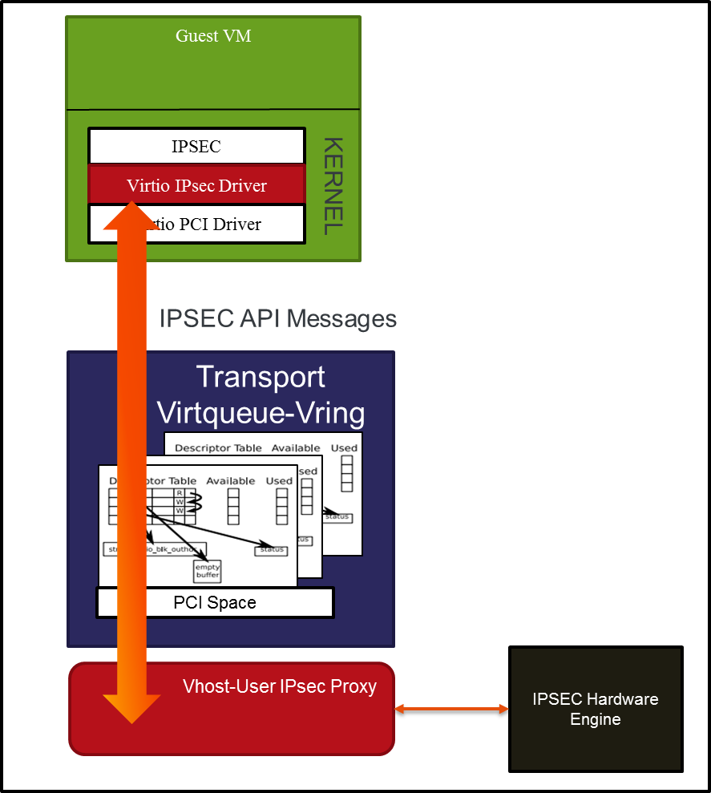
Figure 2 API Messages
As shown in Figure 2, Virtio IPsec driver, sends IPSec API messages through the Virtio/Vring Descriptors to the Vhost-User IPsec Proxy, which interfaces with the IPsec Hardware Accelerator. The API messages for Virtio IPSec is defined in this document.

Virtio IPsec Device Definition
A default Virtio IPsec Device is expected to provide the following functionality:
- IPv4 Support
- Tunnel and Transport Mode
- ESP (Encapsulating Security Protocol)
- Checksum to be calculated for Tunnel packets

A Virtio IPSec Device may exhibit other capabilities such as AH processing etc., through the Virtio PCI Feature specifications.

Bus Details
The bus specific method used to discover this device is Virtio Over PCI bus. The device implements the following parts as per virtio specification
- Device status Field
- Feature bits
- Device Configuration Space
- One or more Virtqueues
The virtio header in the PCI configuration space shall be in PCI and the device header shall follow the endianness as defined by Virtio Standards.
The Virtqueue information (Vring descriptor, available ring, used ring) shall follow the endianness as defined by the Virtio Standards.
The IPsec commands, responses and buffers shall be in Guest Endian Order. The Guest shall inform the endinaness to the Virtio IPsec device using a command.

Virtio Device ID
The device ID used shall be 20
Current specification shows allocated device id’s till 18. For experimental drivers, advise in the spec to choose 20 and work backwards

PCI Device Discovery
The vendor ID and device ID used shall be as follows -
PCI Vendor ID – 0x1AF4
PCI Device ID – (0x1040 + 20) = 0x1054

Feature Bits
An advanced Virtio IPsec device may provide features and functions in addition to a default virtio IPSec device. In such a case the Virtio IPsec device shall exhibit its features using the Virtio PCI features bits
VIRTIO_IPSEC_F_SG_BUFFERS (1) Packet(s) to be IPsec Encrypted/Decrypted can span multiple buffers and hence multiple descriptors; Only the first buffer needs to have the virtio_ipsec_hdr; Rest can have the data
VIRTIO_IPSEC_F_AH (2) Device supports AH
VIRTIO_IPSEC_F_WESP (3) /* Device supports WESP */
VIRTIO_IPSEC_F_SA_BUNDLES (4) /* Device supports SA bundle */
VIRTIO_IPSEC_F_UDP_ENCAPSULATION (5) /* UDP Encapsulation for NAT Traversal */
VIRTIO_IPSEC_F_TFC (6) Device supports Traffic Flow Confidentiality
VIRTIO_IPSEC_F_ESN (7) Device supports Extended Sequence number
VIRITO_IPSEC_F_ECN (8) Device supports Explicit Congestion Notification
VIRTIO_IPSEC_F_DF (9) DF bit support
VIRTIO_IPSEC_F_ANTI_REPLAY_CHECK (10) /* Device supports Anti replay check */
VIRTIO_IPSEC_IPV6_SUPPORT (11) /* Is Support IPv6 */
VIRTIO_IPSEC_F_SOFT_LIFETIME_BYTES_NOTIFY (12) /* Device notifies when soft life time is about to expire, so that Guest can initiate new SA negotiation */
VIRTIO_IPSEC_F_SEQNUM_OVERFLOW_NOTIFY 13 /* Device notifies when sequence number is about to overflow, so that Guest can initiate new SA negotiation */
VIRTIO_IPSEC_F_SEQNUM_PERIODIC_NOTIFY 14 /* Periodic update of Sequence number from device to guest */
The PCI feature bits part of Virtio Standards will be supported.
VIRTIO_RING_F_INDIRECT_DESC 28 /* Support for indirect descriptor table; Refer to Appendix-B, virtio standards */
VIRTIO_RING_F_EVENT_IDX 29 /* Usage of avail_event and used_event fields; Refer to Appendix-B, virtio-standards */

Virtio IPSec Device Configuration Registers
- Two 32 bit registers will be used for the same
  - Register 1 – device queue features; (Read by guest, write by device)
  - Register 2 – guest queue features; (Write by guest, read by device)
- Bit mapping for Register 1 and Register 2
  - Bits 0- Bit 15
    - Should indicate maximum number of encap/decap queue pairs.
    - Maximum possible value = 4k-2 (1 for notification and other for control)
    - Device will initialize value.
  - Bits 16- Bit 19
    - Should indicate maximum number of traffic priority queue pairs.
    - Device will initialize value
    - Guest can read and write back into Register 2
  - Bits 20 – Bit 25 (Max value 64)
    - Should indicate number of queue pairs to achieve device side scaling
    - e.g. if 4 hardware threads of AIOP assigned to one Virtual IPsec instance, then this number would read 4]; e.g. if the accel proxy has 4 threads, this number would read 4.
    - Device will initialize value; Guest modifications in Register 2 will be ignored.
  - Bits 26 – Bit 31 (Max value 64)
    - Should indicate maximum number of queue pairs to achieve guest side scaling.
    - For example if Guest has 4 VCPUs assigned, then the value here would be 4].
    - Device will not initialize a value in Register 1, Guest writes into register 2
    - Guest will indicate the value
- Operation
  - Qemu side
    - Initializes the values in Register 1
  - Guest side (upon probe)
    - Reads the values in Register 1
    - Writes back its selection values in Register 2
  - Guest writes into Register 2 will be ignored or cause a device reset if written into after device is operational.
- Number of Queues
  - LCM of Total VM queues (Guest Side Scaling, Input+Output, DSCP priorities), Device side scaling
  - E.g.: If there are 4 VCPUs assigned to the VM, 3 DSCP priorities, and an input-out pair, the total VM queues = 4 * 3 *2 = 24; If there are 2 Proxy threads assigned, the total number of Vrings would be LCM of 24, and 2, which is 24.
- Implicit agreement between Guest driver/device on the ordering of Queues
  - Queue 0 – Control Queue
  - Queue 1 – Optional Notification Queue
  - The remaining shall be data queues [DQs]
    - For the following parameters, Guest Side Scaling (GS)=x, DSCP Priority (P) = y and Device Side Scaling (DS) = z,
    - Total queues tq = LCM ((x*y*2), z)
    - Device side handling
      - Each proxy thread (without AIOP) or each core (AIOP) would handle tq/z queues
    - Ordering
      - For 4 CPUs, and 3 priorities, assuming the ordering is as follows:
        - VCPU₁ will own queues 1-3 for decapsulation
        - VCPU₁ will own queues 4-6 for encapsulation
        - VCPU₂ will own queues 7-9 for decapsulation
        - VCPU₂ will own queues 10-12 for encapsulation
        - VCPU₂ will own queues 13-15 for decapsulation
        - VCPU₂ will own queues 16-18 for encapsulation
        - VCPU₄ will own queues 19-21 for decapsulation
        - VCPU₄ will own queues 22-24 for decapsulation
    - From device perspective
      - If the device side scaling is 2, then for the above example, Device core 1 will handle ½ the queues (12) and Device core 2 will handle the remaining half.

Virtqueues
The following queues shall be supported
- Control Queue
  - Each Virtio IPsec device shall support one control queue, through which the Guest/driver shall send commands to setup – add, modify, update SAs and other functionality required for a IPsec Look Aside Accelerator
- Notification Queue
  - A virtio IPSec device shall support one notification queue if any of the feature bits VIRTIO_IPSEC_F_SEQNUM_OVERFLOW_NOTIFY, VIRTIO_IPSEC_F_SEQNUM_PERIODIC_NOTIFY or VIRTIO_IPSEC_F_SOFT_LIFETIME_BYTES_NOTIFY is negotiated between the device and driver.
  - If any of the above feature bits are negotiated, the Virtio IPSec device shall use the notification queue to notify the guest driver for any such notifications, when enabled using the Control Queue commands.
- Multiple data Encapsulation, Decapsulation Queues will be supported.
  - For a given VM, the number of data Virtqueues calculation would depend on
    - Number of VCPUs assigned to the VM
    - Number of AIOP/iNIC/Proxy threads available to perform the SEC operation (across VNFs or VMs)
    - DSCP/TOS – traffic classes that need to be supported.
    - For example, if there are 4 VCPUs assigned to the Guest, 2 threads in Proxy (device backend) to perform SEC function and 3 Queues to support DSCP/TOS classes, the total number of virtqueues would be LCM of ((4*3*2), 2) = 24
    - Arrangement of queues is explained as part of the Device Features [Section 5.1.4].
- Default number of queues will be 4 - 1 Command Queue, 2 Data queues (one for IPsec Encapsulation and encryption, the other for IPSec decapsulation and Decryption) and 1 for optional special notifications from device

Device Emulation
The virtio-IPsec device shall use a Vhost-User as a backend. The initialization sequence of the virtio IPsec device would be similar to a vhost-user/virtio-net. To summarize the steps here:
- The device initialization and setup occurs as described in “Device Initialization” in virtio Spec.
- Vrings are determined at initialization. The virtio-ipsec driver in Guest VM allocates the vrings and writes the Guest Physical Address corresponding to this page via iowrite to VIRTIO_PCI_QUEUE_PFN.
- Once “DRIVER_OK” status bit is set in the status register by the driver, the device is live. At this point, vhost-user backend would be hooked with this device.

Invocation of device in QEMU
Specifying the following in the Qemu command line will add the device:
-device virtio-ipsec-pci,queues=<n>
queues is an optional parameter. By default, 4 queues shall be created.
The full invocation may look like :
# Qemu-kvm ….\
-chardev socket,path=/path/to/socket,id=chr0 \
-object <ipsec-dev>, type=vhost-user, chardev-chr0,id=ipsec0 \
-device virtio-ipsec-pci,ipsec-dev=ipsec0
-object memory-backend-file share=on
Multiple instances of the device virtio-ipsec-pci shall be supported in the QEMU invocation.

API Messages between Virtio IPsec driver (Guest driver) and Vhost-User

Feature Bits
Covered in Section 7.2.3

Information in queues
The information sent as structures in the queue (Control, Notification or Data) shall be packed, using C attribute __packed__.

Command Message Format
/*
* IPSec Control virtqueue data structures
*
* The control virtqueue expects a header in the first sg entry
* and an result/status response in the last entry. Data for the
* command goes in between.
* Note: The ctrl_hdr, ctrl_result and the actual command can be sent as a single buffer as well
*/
struct virtio_ipsec_ctrl_hdr {
u8 class; /* class of command */
u8 cmd; /* actual command */
};
Struct virtio_ipsec_ctrl_result {
u8 result; /* VIRTIO_IPSEC_OK or VIRTIO_IPSEC_ERR */
u8 result_data; /* error information if any */
};

/* Defines for the result field */
enum virtio_ipsec_result_value
{
VIRTIO_IPSEC_OK = 0, /* Result is Ok */
VIRTIO_IPSEC_ERR /* Result is an error */
};

Following messages will be sent on the Command Queue:
enum virtio_ipsec_ctrl_command_class
{
VIRTIO_IPSEC_CTRL_GENERIC = 1, /* Generic Commands such as Get/Set Capabilities, Set Endianness etc. */
VIRTIO_IPSEC_CTRL_SA, /* Class of commands to add/modify/delete SA */
VIRTIO_IPSEC_CTRL_GET_RAND_DATA, /* Class of commands to get random data */
VIRTIO_IPSEC_CTRL_ADVANCED /* Any vendor specific or advanced commands */
};

/* Generic commands */
enum virtio_ipsec_ctrl_command_class_generic
{
VIRTIO_IPSEC_CTRL_GET_CAPABILITIES=1, /* Underlying algorithm support */
VIRTIO_IPSEC_CTRL_SET_CAPABILITIES=2, /* Nothing defined here as of now */
VIRTIO_IPSEC_CTRL_SET_GUEST_ENDIAN=3 /* Set the Guest endian mode to device */
};

/* SA Commands */
enum virtio_ipsec_ctrl_command_class_sa
{
VIRTIO_IPSEC_CTRL_ADD_OUT_SA=1, /* Add an outbound SA – Encapsulation */
VIRTIO_IPSEC_CTRL_DEL_OUT_SA, /* Delete Outbound SA */
VIRTIO_IPSEC_CTRL_UPDATE_OUT_SA, /* Update Outbound SA */
VIRTIO_IPSEC_CTRL_READ_OUT_SA, /* Read Outbound SA */
VIRTIO_IPSEC_CTRL_READ_FIRST_N_OUT_SAs /* Read first N outbound SAs */
VIRTIO_IPSEC_CTRL_READ_NEXT_N_OUT_SAs /* Read next N Out SAs */
VIRTIO_IPSEC_CTRL_ADD_IN_SA, /* Add an inbound SA – Decapsulation */
VIRTIO_IPSEC_CTRL_DEL_IN_SA, /* Delete Inbound SA */
VIRTIO_IPSEC_CTRL_UPDATE_IN_SA, /* Update Inbound SA */
VIRTIO_IPSEC_CTRL_READ_IN_SA, /* Read Inbound SA */
VIRTIO_IPSEC_CTRL_READ_IN_SA, /* Read In SA */
VIRTIO_IPSEC_CTRL_READ_FIRST_N_IN_SAs, /* Read first N SAs */
VIRTIO_IPSEC_CTRL_READ_NEXT_N_IN_SAs /* Read Next N SAs */
};
/* Random Number */
enum virtio_ipsec_ctrl_command_class_rand
{
VIRTIO_IPSEC_GET_RAND_NUM=1
};

Control Queue

GET_CAPABILITIES
The below would be used as bit positions in the capabilities
enum virtio_ipsec_hmac_algorithms {
VIRTIO_IPSEC_HMAC_NULL=0,
VIRTIO_IPSEC_HMAC_MD5,
VIRTIO_IPSEC_HMAC_SHA1,
VIRTIO_IPSEC_HMAC_AES_XCBC_MAC,
VIRTIO_IPSEC_HMAC_SHA256,
VIRTIO_IPSEC_HMAC_SHA384,
VIRTIO_IPSEC_HMAC_SHA512,
VIRTIO_IPSEC_HMAC_SHA1_160
};
enum virtio_ipsec_cipher_alogithms {
VIRTIO_IPSEC_CIPHER_NONE=0,
VIRTIO_IPSEC_CIPHER_DES,
VIRTIO_IPSEC_CIPHER_3DES,
VIRTIO_IPSEC_CIPHER_ESP_NULL,
VIRTIO_IPSEC_CIPHER_AES,
VIRTIO_IPSEC_CIPHER_AESCTR,
VIRTIO_IPSEC_CIPHER_AES_CCM_ICV8,
VIRTIO_IPSEC_CIPHER _AES_CCM_ICV12,
VIRTIO_IPSEC_CIPHER_AES_CCM_ICV16 ,
VIRTIO_IPSEC_CIPHER_AES_GCM_ICV8,
VIRTIO_IPSEC_AES_GCM_ICV12 ,
VIRTIO_IPSEC_AES_GCM_ICV16,
VIRTIO_IPSEC_NULL_AES_GMAC
};
struct virtio_ipsec_ctrl_capabilities {
/* Algorithm capabilities */
u32 hmac_algorithms;
u32 cipher_algorithms;
};

SET_GUEST_ENDIAN
enum virtio_ipsec_endian
{
VIRTIO_IPSEC_GUEST_LITTLE_ENDIAN=1,
VIRTIO_IPSEC_GUEST_BIG_ENDIAN 2
};
struct virtio_ipsec_set_guest_endian {
u8 endian; /* GUEST_LITTLE_ENDIAN or GUEST_BIT_ENDIAN */
};

ADD OUT_SA
/* Authentication Algorithms */
/* Refer to enum structure in Get Capabilities Command class */

/* Encryption Algorithms */
/* Refer to enum structure in Get Capabilities Command Class */

#define VIRTIO_IPSEC_NOUNCE_LEN 16
#define VIRTIO_IPSEC_MAX_CIPHER_KEY_SIZE 64

enum virtio_ipsec_qos_dscp_setting
{
VIRTIO_IPSEC_QOS_DSCP_COPY=0,
VIRTIO_IPSEC_QOS_DSCP_CLEAR,
VIRTIO_IPSEC_QOS_DSCP_SET
};

enum virtio_ipsec_df_setting
{
VIRTIO_IPSEC_DF_COPY=0
VIRTIO_IPSEC_DF_CLEAR,
VIRTIO_IPSEC_DF_SET
};

enum virtio_ipsec_transforms
{
VIRTIO_IPSEC_ESP=0,
VIRTIO_IPSEC_AH,
VIRTIO_IPSEC_ESP_WITH_AH
};

#define VIRTIO_IPSEC_SA_HANDLE_SIZE 8 /* in bytes */

#define VIRTIO_IPSEC_TUNNEL_HDR_IS_IPV4 0
#define VIRTIO_IPSEC_TUNNEL_HDR_IS_IPV6 1

#define VIRTIO_IPSEC_SA_SAFLAGS_TUNNEL_MODE 0
#define VIRTIO_IPSEC_SA_SAFLAGS_TRANSPORT_MODE 1

#define VIRTIO_IPSEC_SA_PARAMS_PROTO_ESP 50
#define VIRTIO_IPSEC_SA_PARAMS_PROTO_AH 51

#define VIRTIO_IPSEC_PROPOGATE_ECN_ON 0
#define VIRTIO_IPSEC_PROPOGATE_ECN_OFF 1

#define VIRTIO_IPSEC_REPLAY_CHECK_ON 0
#define VIRTIO_IPSEC_REPLAY_CHECK_OFF 1

#define VIRTIO_IPSEC_UDP_ENCAPSULATION_ON 0
#define VIRTIO_IPSEC_UDP_ENCAPSULATION_OFF 1

#define VIRTIO_IPSEC_UDP_NAT_TRAVERSAL_V1 0
#define VIRTIO_IPSEC_UDP_NAT_TRAVERSAL_V2 1

struct virtio_ipsec_sa_params {
u32 ulSPI; /* Security Parameter Index */
u16 /* Flags */

bEncapsulationMode:1,
bIPv4OrIPv6;
bUseExtendedSeqNum:1,
bDoAntiReplayCheck:1,
bDoUDPEncapsulation:1,
bTransforms:2, /* 00=ESP, 01=AH, 10 = ESP+AH */
bNotifySoftLifeKBExpiry:1, /* Notify when soft life time expires */
bNotifyBeforeSeqNumOverlfow:1, /* Notify ‘n’ packets before Seq number expires */
bNotifySeqNumPeriodic:1; /* Notify Periodically every ‘n’ packets */

u32 antiReplayWin;
}

/* The following structures may be used following the virtio_ipsec_sa_params, based
on the bit field settings */

struct virtio_ipsec_tunnel_hdr_ipv4
{
u32 saddr; /* Source Address */
u32 daddr; /* Destination Address */
u8 bCopyDscp:1,
bHandleDf:2,
bPropogateECN:1;
u8 Dscp; /* Value to be used for creating DSCP field in Outer IP header */
};

struct virtio_ipsec_tunnel_hdr_ipv6
{
u32 s_addr[4]; /* Source Address */
u32 d_addr[4]; /* Destination Address */
u8 b_copy_dscp:1,
b_handle_df:2,
b_propogate_ECN:1;
u8 Dscp; /* Value to be used for creating DSCP field in Outer IP header */
};

/* Structure to hold NAT Traversal information */
struct virtio_ipsec_udp_encapsulation_info
{
u8 ulNatTraversalMode; /* v1 or v2 */
u16 d_port; /* Destination Port Value */
u16 s_port; /* Source Port Value */
};
/* Structure to hold variable length data; Can be used for sending keys etc. */
struct virtio_ipsec_lv
{
u32 len; /* Length of following data */
u8 data[0]; /* actual data */
}
struct virtio_ipsec_esp_info
{
u8 ulflags reserved:4,
bAuth:1,
bEncrypt:1;
u8 cipher_algo; /* Encryption algorithm as defined in Get Features */
u8 IV_Size;
u8 block_size;
struct virtio_ipsec_lv cipher_key;
u32 counter_initial; /* Initial counter for counter mode algorithms */
u8 auth_algo; /* Authentication Algorithm as defined in Get Features */
struct virtio_ipsec_lv auth_key;
u8 AHPaddingLen;
u8 ICVSize;
struct virtio_ipsec_lv nounce_IV;
}

struct virtio_ipsec_ah_info
{
u8 authAlgo;
struct virtio_ipsec_lv auth_key;
u8 AHPaddingLen;
u8 ICVSize;
}

struct virtio_ipsec_create_sa{
u32 sa_handle[VIRTIO_IPSEC_SA_HANDLE_SIZE]; /* Output */
struct virtio_ipsec_sa_params sa_params; /* Input */
/* Followed by structures based on the flag bits in sa_params */
};
The structures that follow struct virtio_ipsec_sa_params depend on the flags member of the structure.
- If bEncaspulationMode is set to
  - VIRTIO_IPSEC_SA_SAFLAGS_TUNNEL_MODE, the next structure would be either struct virtio_ipsec_tunnel_hdr_ipv4 or struct virtio_ipsec_tunnel_hdr_ipv6 based on the bIPv4OrIPv6 flag setting.
- If bTransforms is set to
  - VIRTIO_IPSEC_ESP, the next structure would be struct virtio_ipsec_esp_info
  - VIRTIO_IPSEC_AH, the next structure would be struct virtio_ipsec_ah_info
  - VIRTIO_IPSEC_ESP_WITH_AH, the next structure would be struct virtio_ipsec_esp_info followed by struct virtio_ipsec_ah_info
- If bDoUDPEncapsulation is set to VIRTIO_IPSEC_UDP_ENCAPSULATION_ON
  - The next structure to follow would be struct virtio_ipsec_udp_encapsulation_info
- If bNotifySoftLifeKBExpiry is set
  - The next structure to follow would be struct virtio_ipsec_notify_lifetime_kb
- If bNotifyBeforeSeqNumOverflow is set
  - The next structure to follow would be virtio_ipsec_notify_before_seqnum_overflow
- If bNotifySeqNumPeriodic is set
  - The next structure to follow would be virtio_ipsec_notify_before_seqnum_overflow

ADD_IN_SA
struct virtio_ipsec_create_in_sa{
u32 sa_handle[VIRTIO_IPSEC_SA_HANDLE_SIZE];
struct virtio_ipsec_sa_params sa_params;
/* Followed by structures based on flag member of sa_params; */
/* Refer to Section 8.2.1.3, the set of structures that follow depend on the flag settings in that order */
};

UPDATE SA
/* Capability – update */
struct virtio_ipsec_update_sa_ipaddr_v4 {
u16 port;
u32 addr;
}
struct virtio_ipsec_update_sa_ipaddr_v6{
u16 port;
u32 addr;
}

#define VIRTIO_IPSEC_UPDATE_SA_LOCAL_GW 0
#define VIRTIO_IPSEC_UPDATE_SA_PEER_GW 1
struct virtio_ipsec_update_sa {
u8 changeType; /* LOCAL_GW, REMOTE_GW */
u32 sa_handle[VIRTIO_IPSEC_SA_HANDLE_SIZE];
/* The structure that follows would be either virtio_ipsec_update_sa_ipaddr_v4 or virtio_ipsec_update_sa_ipaddr_v6 based on whether the updated SA is an ipv4 or ipv6 SA.
};

DELETE SA
struct virtio_ipsec_delete_sa{
u32 sa_handle[VIRTIO_IPSEC_SA_HANDLE_SIZE];
};

READ OUT_SA
struct virtio_ipsec_out_sa_info {
u32 low_seq_number;
u32 hi_seq_number;
};
struct virtio_ipsec_read_out_sa_exact {
u32 sa_handle[VIRTIO_IPSEC_SA_HANDLE_SIZE];
struct virtio_ipsec_out_sa_info info;
struct virtio_ipsec_sa_params sa_params;
/* Followed by structures based on the flag bits in sa_params */
};

READ_FIRST_N_OUT_SA
struct virtio_ipsec_read_out_n_first_sa {
u32 num_sas;
u32 opaque_handle[VIRTIO_IPSEC_SA_HANDLE_SIZE]; /* Output by Accelerator; Input for next n calls */
Array of [
u32 sa_handle[VIRTIO_IPSEC_SA_HANDLE_SIZE];
struct virtio_ipsec_out_sa_info info;
struct virtio_ipsec_sa_params sa_params;
/* Followed by structures based on the flag bits in sa_params */
]
};

READ_NEXT_N_OUT_SA
struct virtio_ipsec_read_out_n_next_sa {
u32 num_sas;
u32 opaque_handle[VIRTIO_IPSEC_SA_HANDLE_SIZE]; /* Output by Accelerator; Input for next n calls */
Array of [
u32 sa_handle[VIRTIO_IPSEC_SA_HANDLE_SIZE];
struct virtio_ipsec_out_sa_info info;
struct virtio_ipsec_sa_params sa_params;
/* Followed by structures based on the flag bits in sa_params */]
};

READ IN_SA
struct virtio_ipsec_in_sa_info {
u32 low_seq_number;
u32 hi_seq_number;
};
struct virtio_ipsec_read_in_sa_exact {
u32 sa_handle[VIRTIO_IPSEC_SA_HANDLE_SIZE];
struct virtio_ipsec_in_sa_info info;
struct virtio_ipsec_sa_params sa_params;
/* Followed by structures based on the flag bits in sa_params */
};

READ_FIRST_N_IN_SA
struct virtio_ipsec_read_in_n_first_sa {
u32 num_sas;
u32 opaque_handle[VIRTIO_IPSEC_SA_HANDLE_SIZE]; /* Output by Accelerator; Input for next n calls */
Array of [
u32 sa_handle[VIRTIO_IPSEC_SA_HANDLE_SIZE];
struct virtio_ipsec_in_sa_info info;
struct virtio_ipsec_sa_params sa_params;
/* Followed by structures based on the flag bits in sa_params */
]
};

READ_NEXT_N_IN_SA
struct virtio_ipsec_read_in_n_next_sa {
u32 num_sas;
u32 opaque_handle[VIRTIO_IPSEC_SA_HANDLE_SIZE]; /* Output by Accelerator; Input for next n calls */
Array of [
u32 sa_handle[VIRTIO_IPSEC_SA_HANDLE_SIZE];
struct virtio_ipsec_in_sa_info info;
struct virtio_ipsec_sa_params sa_params;
/* Followed by structures based on the flag bits in sa_params */
]
};

Notification Queue
Three optional notification messages can be sent by the device to the Guest driver.
enum virtio_ipsec_notify_event
{
VIRTIO_IPSEC_NOTIFY_LIFETIME_KB_EXPIRY=1,
VIRTIO_IPSEC_NOTIFY_BEFORE_SEQNUM_OVERFLOW,
VIRTIO_IPSEC_NOTIFY_ SEQNUM_PERIODIC
}

VIRTIO_IPSEC_NOTFIY_LIFETIME_KB_EXPIRY
When this notification message is sent by device to Guest, the following structure will be queued in the Notification Queue
struct virtio_ipsec_notify_lifetime_kb_expiry
{
struct enum virtio_ipsec_notify_event; /* Value = VIRTIO_IPSEC_NOTIFY_LIFETIME_KB_EXPIRY */
u32 sa_context_handle[VIRTIO_IPSEC_SA_HANDLE_SIZE];
u32 lifetime_in_kb; /* Current Lifetime in Kb */
};

VIRTIO_IPSEC_NOTIFY_BEFORE_SEQNUM_OVERFLOW
When this notification message is sent by device to guest, the following structure will be queued in the Notification Queue.
struct virtio_ipsec_notify_before_seqnum_overflow
{
struct enum virtio_ipsec_notify_event; /* Value = VIRTIO_IPSEC_NOTIFY_BEFORE_SEQNUM_OVERFLOW */
u32 sa_context_handle[VIRTIO_IPSEC_SA_HANDLE_SIZE];
u32 seqnum; /* Current Sequence Number */
};

VIRTIO_IPSEC_NOTIFY_SEQNUM_PERIODIC
Struct virtio_ipsec_notify_periodic_seqnum
{
struct enum virtio_ipsec_notify_event; /* Value = VIRTIO_IPSEC_NOTIFY_SEQNUM_PERIODIC */
u32 sa_context_handle[VIRTIO_IPSEC_SA_HANDLE_SIZE];
u32 seqnum; /* Current sequence number */
};

Data Queue
Packets are IPSec-encrypted by placing them in the EncryptQ1…EncryptQn and decrypted by placing them in the DecryptQ1..DecryptQn. In each case, the data is preceded by a header. When data is spread across a SG list, only the first buffer shall have the virtio_ipsec_hdr. The rest of the buffers will have only data.
struct virtio_ipsec_hdr {
u32 sa_context_handle[[VIRTIO_IPSEC_SA_HANDLE_SIZE]; /* IPsec SA Context */
u32 num_input_buffers; /* Number of input buffers */
u32 input_data_length; /* Length of input data */
u32 num_output_buffers; /* Number of output buffers */
u32 output_buffer_length; /* Size of output buffers */
u32 flags; /* for future use */
u32 output_data_length; /* Output data length */
u32 result;
u32 error_code;
};
Following the header there will be the descriptors pointing to the input buffer, followed by descriptors pointing to the output buffer.
Desc-1
Desc-2
Desc-3
Desc-4
Desc-5
struct virtio_ipsec_hdr
Input Buffer1
Input Buffer 2
Output Buffer 1
Output Buffer 2
Figure 3 Example descriptor chain
Figure 6 shows an example descriptor chain. The first descriptor points to the struct virtio_ipsec_hdr, that contains the buffer information and results. The next 2 descriptors point to input buffers. The last 2 descriptors point to the Output buffers.

Note: As the descriptor queue size supported is 64k (16 bit space), there is no need to use the Indirect Descriptors. SG descriptors shall be made use of.

Live Migration States
TBD

Libvirt Integration

<devices>
<ipsec model='virtio'>
<queues=6/>
<backend model='vhostuser'>
<source type='unix' path='/tmp/vhost.sock' mode='server'/>
<model type='virtio'/>
</backend>
</ipsec>
</devices>
Name of the device “ipsec”.
Optional parameter – queues – If this option is not specified, by default 3 queues will be created.
Backend – of type vhostuser
The <source> element has to be specified along with the type of char device. Currently, only type='unix' is supported, where the path (the directory path of the socket) and mode attributes are required. Both mode='server' and mode='client' are supported. vhost-user requires the virtio model type, thus the <model> element is mandatory.

IPsec Packet Processing – Look Aside Accelerator Packet Flow
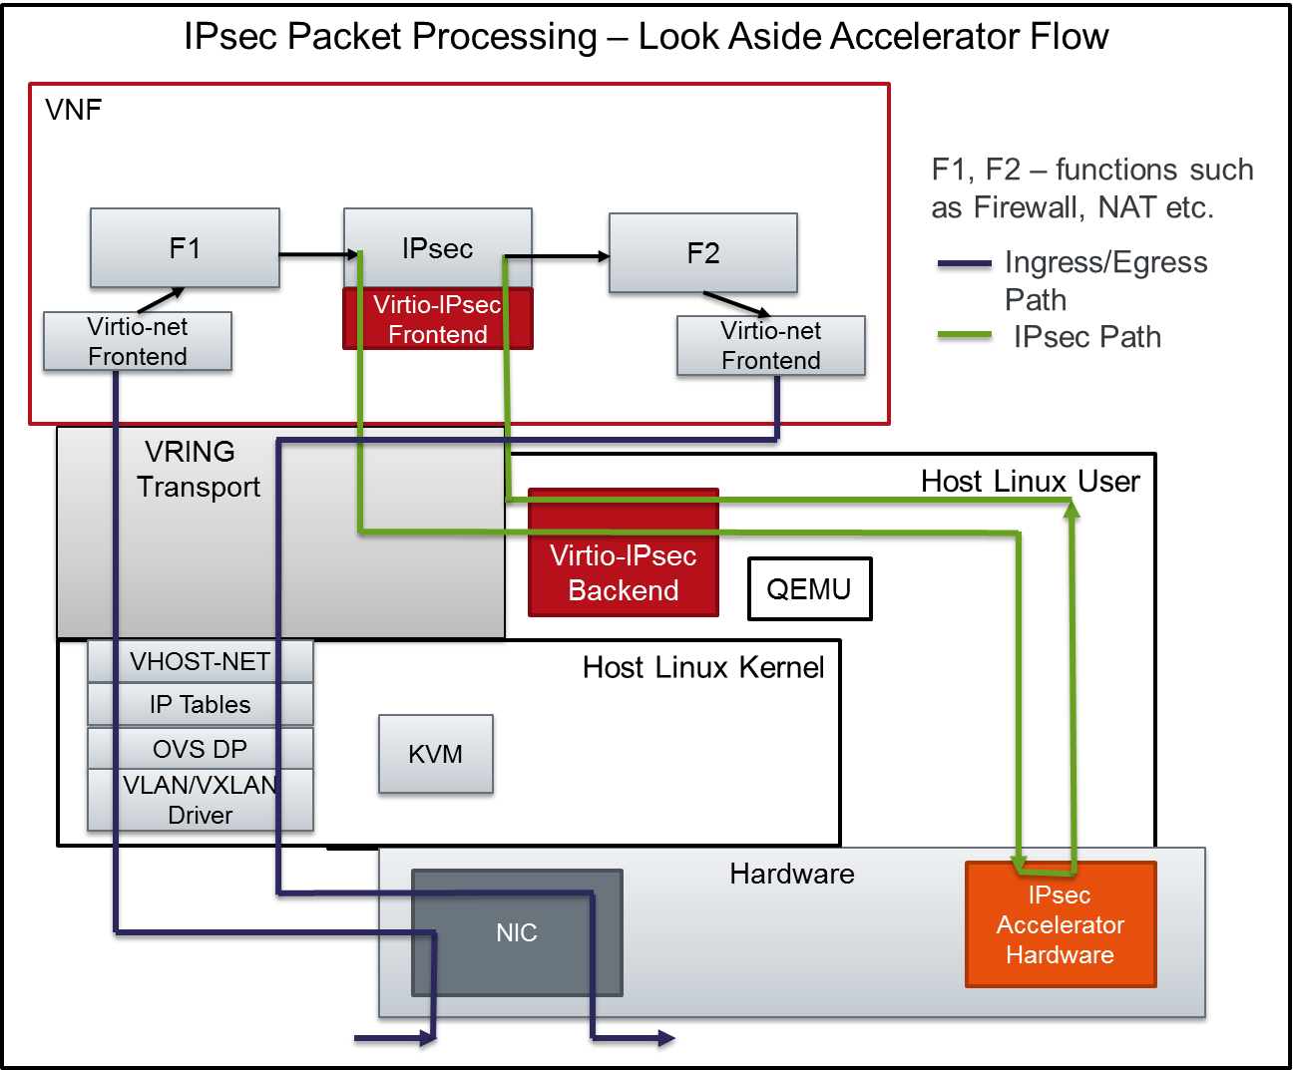
Figure 5 IPsec Packet Processing –Look Aside Accelerator Flow
Figure 4 shows the flow of packets when IPsec Look aside accelerator is used. F1, F2 stand for several packet processing functions such as Firewall, NAT etc.
Ingress Packet Flow:
- Packets processed by VXLAN/VLAN, OVS Data Path, IP Tables, Vhost-Net
- Packet announced to VNF through Virtio-Net driver
- Packets under several function processing such as Firewall etc.
- Packets arrive at the IPsec module for IPsec Packet Processing
- As packets are submitted by the IPsec Module to the Virtio-IPsec front end driver, the buffers are put in the Virtio Descriptor Vrings or Virt Qs to be transferred to the Virtio-IPsec Backend.
- The Virtio IPSec Backend is responsible for translating the packets from Virt Q Descriptor to the actual hardware accelerator in a message that the accelerator understands and vice-versa.
- The Virtio IPsec Backend is also responsible for picking up processed packets from the hardware accelerator, updating the VirtQ rings and notifying the Guest VNF.
- The processed packets under further processing functions (F2 etc.) before being sent out through the Virtio interface.

