Acceleration Interface for VNFs – IPsec and Packet Processor Use Case

Revision History

Date | Version | Author | Reason
03/05/2015 | 1 | Freescale Semiconductor | Initial version
09/11/2015 | 2 | Freescale Semiconductor | Including Virtio-IPsec requirements, APIs and Messages

Table of Contents
Table of Contents 3
1 Need Description 4
2 References 5
3 Classification 5
3.1 Acceleration Models 5
3.1.1 Look Aside Model 5
3.1.2 Offload Model 5
4 Virtio based Accelerators 6
4.1 Look aside Accelerator 6
4.1.1 Look aside Functions 7
4.1.2 IPsec Packet Processing – Look Aside Accelerator Packet Flow 8
4.1.3 IPsec Packet Processing - NFVI Packet Processing Accelerator 9
4.2 Offload Accelerators 11
4.2.1 Offload Functions 12
4.2.2 IPsec Packet Processing - NFVI and IPsec Offload Accelerator 13
5 Performance Benefits 14
6 Management & Orchestration Requirements 15
7 Possible Accelerators 15
8 Live migration Consideration 15

Need Description
With NFVI (Network Functions Virtualization Infrastructure), Virtual Network Functions (VNFs) run as software-only entities in a hardware agnostic fashion. Examples of VNF range from
- Switching, Routing
- CDNs
- Security application such as Firewall, Intrusion Prevention systems, Virus and SPAM Protection Systems, IPsec and SSL-VPN gateways.
- eNodeB
- EPC SGW, PGW

While a range of VNFs may work efficiently as software-only entities, several of the VNFs such as IPS (Intrusion Detection and Prevention Systems), WAF (Web Application Firewalls that do virus scanning and spam protection), IPsec/SSL-VPN Gateways, LTE requiring Packet Data Convergence Protocol (PDCP) processing and VoIP (Voice over IP) Gateways do compute intensive algorithmic operations that takes away cycles off the VNFs. Achieving high performance for the above mentioned collective umbrella of Compute Intensive applications (CI) is a known challenge when run as VNFs.
Different CI VNFs require specific type of offload accelerators. The table below cites some examples of CI VNFs and the accelerators that they will need.
 | VNF Application | Offload Accelerator Capabilities
1 | IPsec/SSL Gateway | Symmetric Key Cryptography, Public Key Cryptography  IPsec Protocol Accelerators, SSL Record Layer Accelerators
2 | Intrusion Prevention Systems | Pattern matching, compression, decompression
3 | Web Application Firewall, Anti-Virus, Anti-Spam Systems | Compression, decompression, pattern matching, SSL Record Layer Processing, Public and Symmetric Cryptography.
4 | Packet Data Convergence Protocol | Crypto engines  Protocol Acceleration
5 | VOIP Gateway | Crypto engines  SRTP Protocol Acceleration
6 | Routing, Firewall | Table lookup Accelerators

The CI applications that run on propriety complex hardware-based physical appliances showcase higher performance as the compute intensive algorithmic operations (e.g. cryptography, compression/decompression, pattern matching) are offloaded to the hardware accelerators of SoCs. The major stumbling block in providing hardware acceleration for these CIs as VNFs is that the hardware accelerators available today have proprietary vendor specific interfaces that defeat the basic goal of NFV that envisages VNFs to be run as a software-only entity in a hardware agnostic fashion.
Keeping the requirement of VNF to achieve high performance virtualized network appliances which are portable between different hardware vendors, it becomes imperative to define a standard vendor independent accelerator interface, Virtual Accelerator Interface, so that VNFs shall continue to exist as software-only entities and work in a hardware agnostic fashion and yet address the performance challenges for the CI applications as VNFs.
In summary, the problem statement is as follows:
- CI VNFs are unable to showcase high performances as traditional CIs as they run as software-only entities. Using accelerators is one method with which CI VNFs can showcase higher performance as their traditional counter-parts.

- CI VNFs are unable to make use of hardware accelerators as they have proprietary vendor-specific interfaces and using such proprietary interfaces defeats the portability and migration requirements of VNFs across various ecosystems.

References
Virtio Specifications http://docs.oasis-open.org/virtio/virtio/v1.0/virtio-v1.0.pdf

Classification

Acceleration Models
There are multiple criteria based on which accelerators can be classified. One criteria used for classification depends on amount of packet processing done on the VNF and the hardware accelerator. Based on this criteria, accelerators can be classified into Look aside accelerators and Offload accelerators.

Look Aside Model
In this model, the VNF application processes some amount of packet processing by itself before making use of an available accelerator to do some aspects of the packet processing

Accelerator Functions
There can be several examples of lookaside accelerator functions such as Crypto, IPsec-header processing, SSL-Header processing, PME (Pattern Matching) and so on.

Offload Model
In this model, the VNF application typically pushes all the states to the offload accelerator and allows the accelerator to perform the packet processing in an autonomous fashion. This model is also referred to as cut-through model. In this case the VNF application expects to process few packets such as exception packets.

Accelerator Functions
Examples of offload accelerator functions include Firewall, SLB, NAT, IPsec etc.

Virtio based Accelerators

Look aside Accelerator
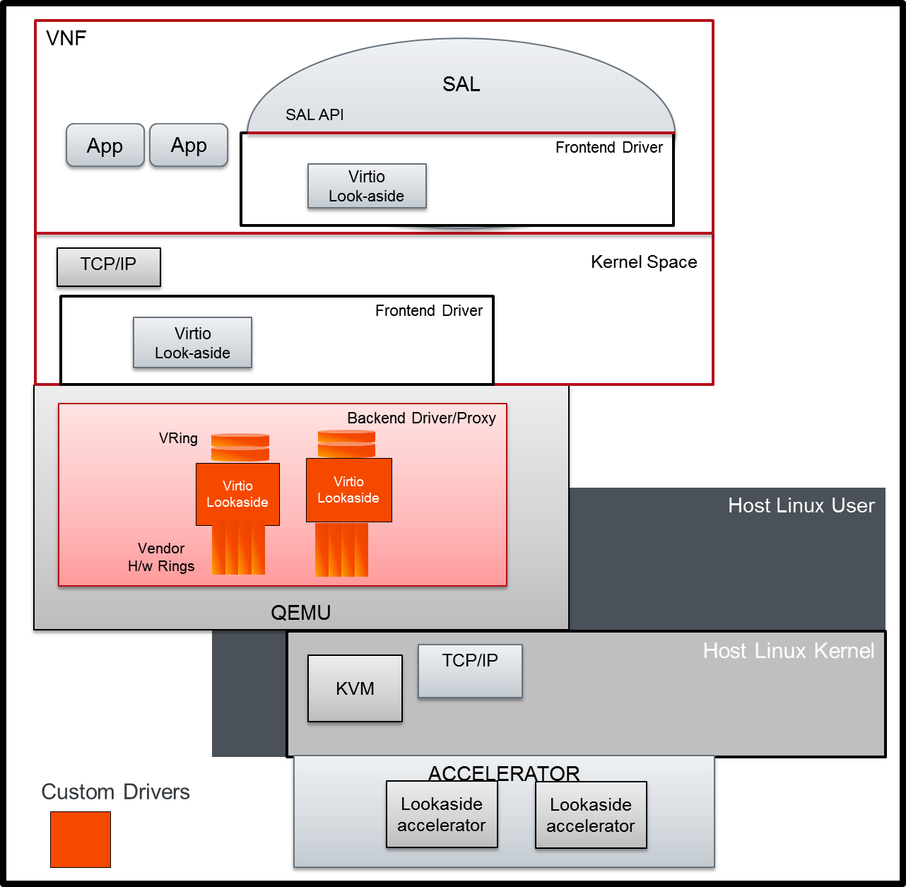
Figure 1 Virtio Look aside Interface for Accelerator
Figure 1 shows a suggested implementation of standardized accelerator available for VNFs using Virtio . Under the Virtio-lookaside model (umbrella of drivers), VNF can access several look aside accelerator functions such as IPsec, Crypto, PME, DCE etc.

Look aside Functions
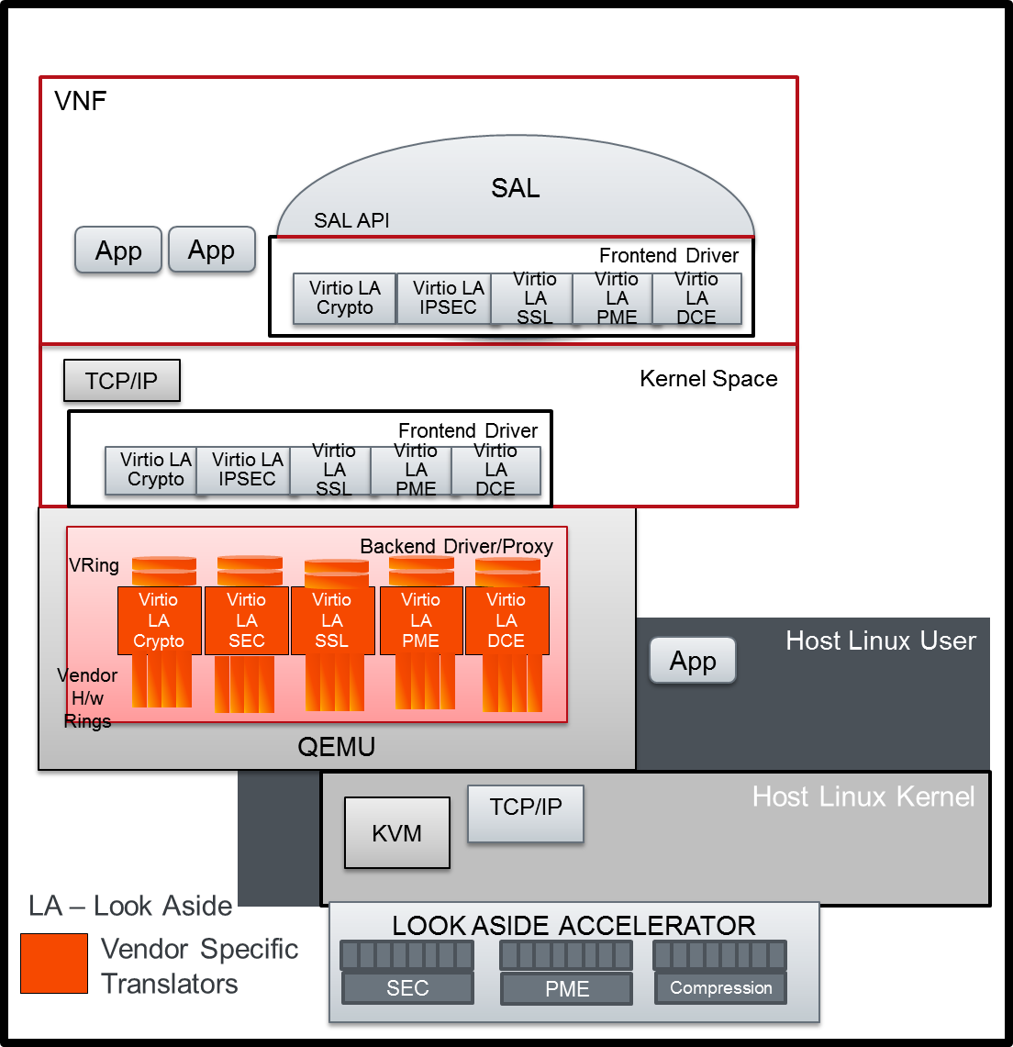
Figure 2: Standardized Look aside Accelerator Interface using virt-io drivers
Figure 2 shows Virtio-lookaside function specific drivers enabling a VNF to access underlying hardware accelerators in a hardware agnostic fashion.
Several Virtio-accelerator function drivers (LA or Look Aside model) are shown in the picture – namely Virtio LA Crypto (for Crypto operations), Virtio LA IPsec (for IPsec level acceleration), Virtio LA SSL (for SSL level operations), and Virtio LA PME for pattern matching acceleration and Virtio LA DCE for compression, de-compression operations.
The backend would include vendor specific translators that translate the generic virtio messages to vendor specific messages, hence enabling the VNFs access to the underlying accelerators

IPsec Packet Processing – Look Aside Accelerator Packet Flow
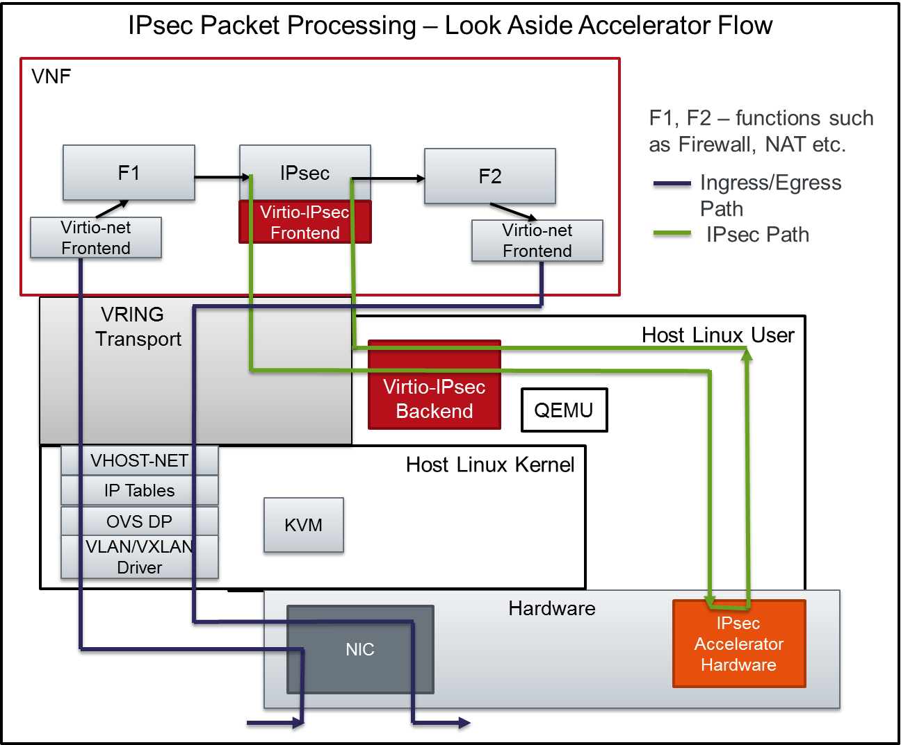
Figure 3 IPsec Packet Processing –Look Aside Accelerator Flow
Figure 4 shows the flow of packets when IPsec Look aside accelerator is used. F1, F2 stand for several packet processing functions such as Firewall, NAT etc.
Ingress Packet Flow:
- Packets processed by VXLAN/VLAN, OVS Data Path, IP Tables, Vhost-Net
- Packet announced to VNF through Virtio-Net driver
- Packets under several function processing such as Firewall etc.
- Packets arrive at the IPsec module for IPsec Packet Processing
- As packets are submitted by the IPsec Module to the Virtio-IPsec front end driver, the buffers are put in the Virtio Descriptor Vrings or Virt Qs to be transferred to the Virtio-IPsec Backend.
- The Virtio IPSec Backend is responsible for translating the packets from Virt Q Descriptor to the actual hardware accelerator in a message that the accelerator understands and vice-versa.
- The Virtio IPsec Backend is also responsible for picking up processed packets from the hardware accelerator, updating the VirtQ rings and notifying the Guest VNF.
- The processed packets under further processing functions (F2 etc.) before being sent out through the Virtio interface.

IPsec Packet Processing - NFVI Packet Processing Accelerator
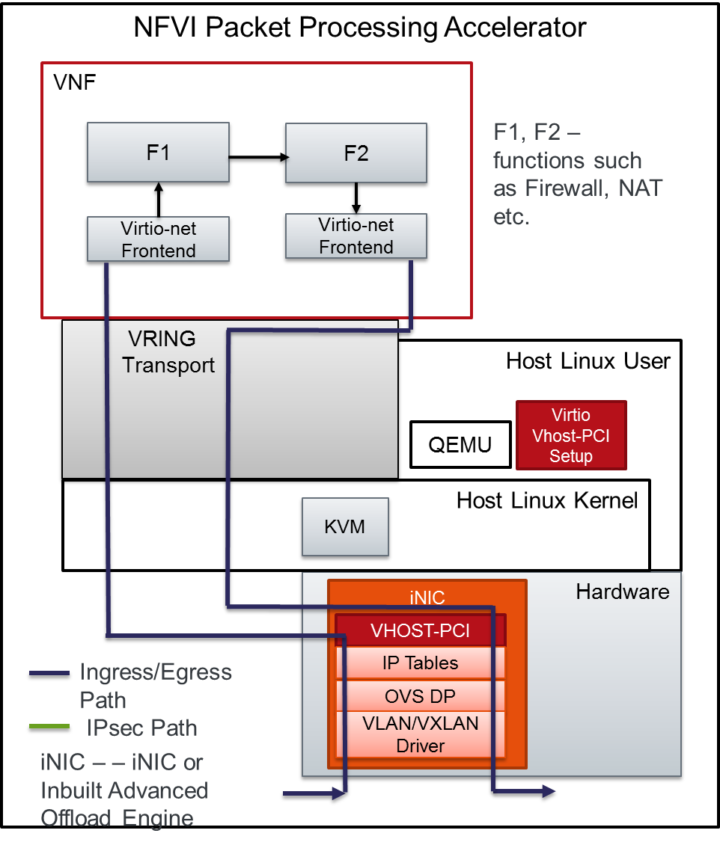
Figure 4 NFVI Packet Processing Accelerator
Figure 5 shows the packet flow for a NFVI Packet Processing Accelerator. The packet flow in this case is as follows:
- VXLAN/VLAN, OVS Data Plane, IP Tables processing happens in the Intelligent NIC (iNIC). The Vhost-PCI backend presents the packets to the VNF using the Virtio-net interface
- Packets that need to be transmitted out are submitted through the Virtio-Interface. The Vhost-PCI backend handles the packet, does the necessary processing before sending the packet out.

Combined NFVI Packet Processing with IPsec Look Aside Accelerator
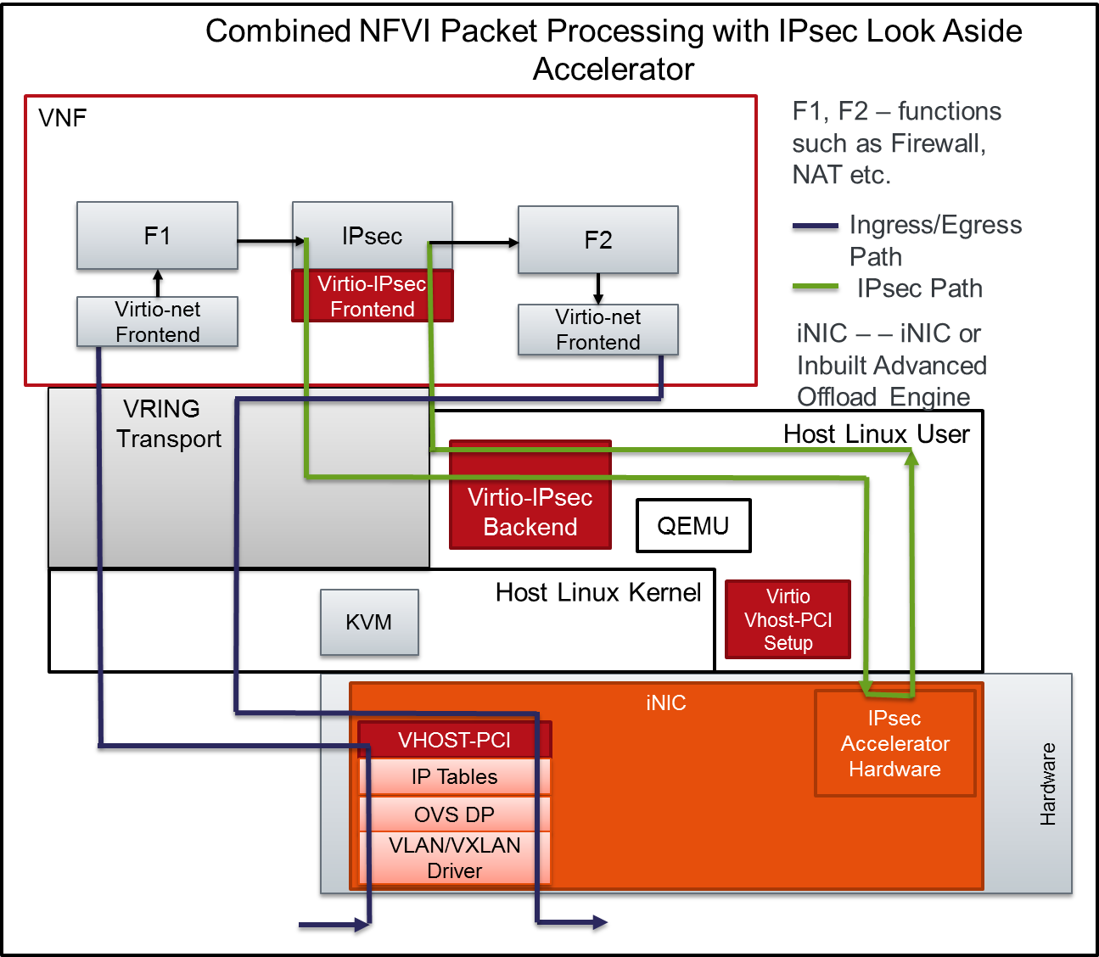
Figure 5 Combined NFVI Packet Processing with IPsec Look Aside Accelerator
Figure 6 shows the packet flow of a combined case of NFVI Acceleration and IPSec Look Aside Acceleration.

Offload Accelerators
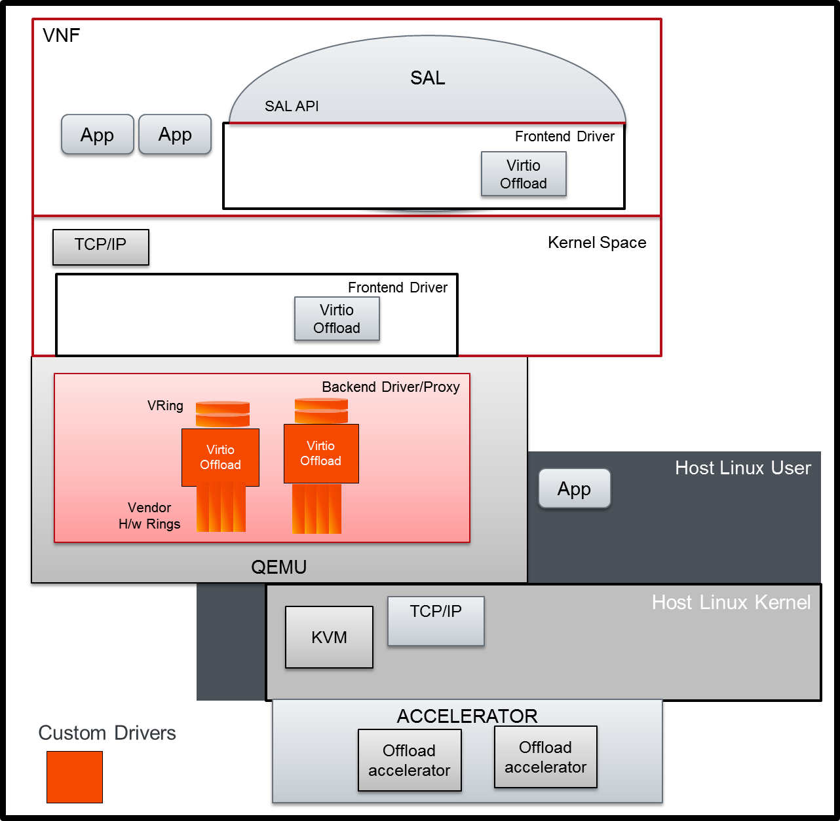
Figure 3 Virtio Offload Interface for Accelerator
Figure-3 shows the Offload accelerator interface. Under the Virtio-offload model (umbrella of drivers), the VNF can access several offload functions such as Firewall Offload function, SLB-NAT Offload function, IPSec offload function etc.
VNF applications in the Guest User space can make use of the SAL interface implementing Virtio-Accelerator specific frontend drivers to access the underlying hardware accelerator. VNF Applications residing the Guest Kernel space can make use of the virtio frontend driver in the kernel level to access the underlying hardware accelerator.

Offload Functions

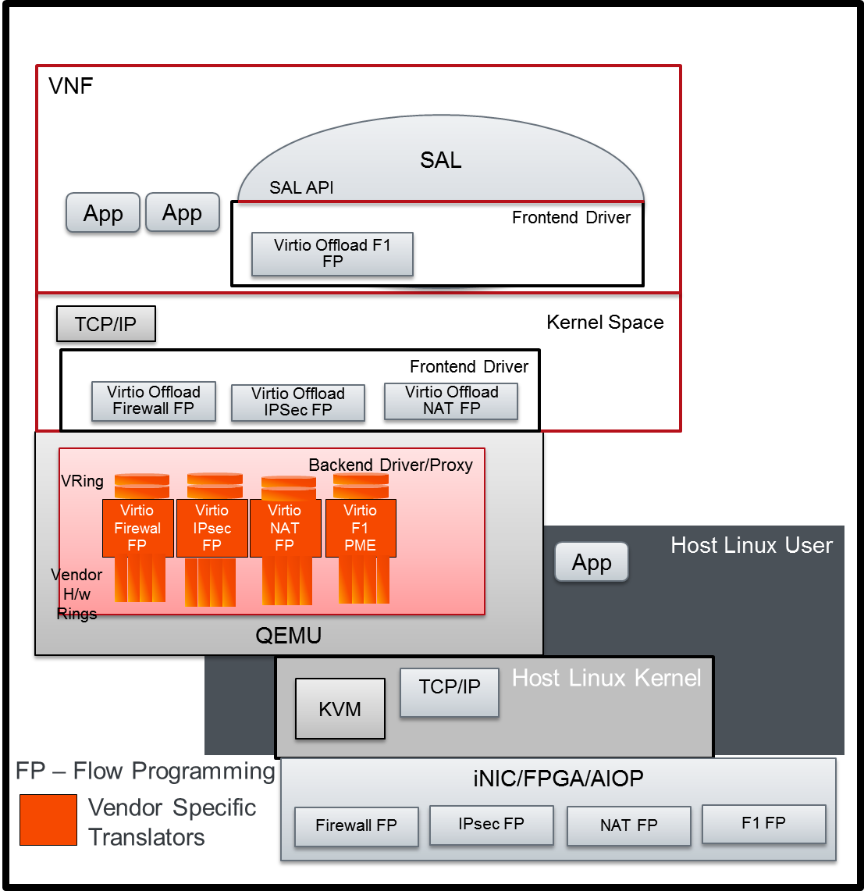
Figure 4 Virtual Accelerator Interface for Offload Model
Figure 4 shows a suggested implementation of standardized offload model interfaces available to VNFs using Virt-IO drivers.
Several virtio-offload function drivers are shown in the picture – namely Virtio Firewall flow programming, Virtio IPsec Flow Programming, Virtio NAT flow programming etc.
The backend would include vendor specific translators that translate the generic virtio messages to vendor specific messages, hence enabling the VNFs access to the underlying accelerators.

IPsec Packet Processing - NFVI and IPsec Offload Accelerator

Complete Offload – Packet flow
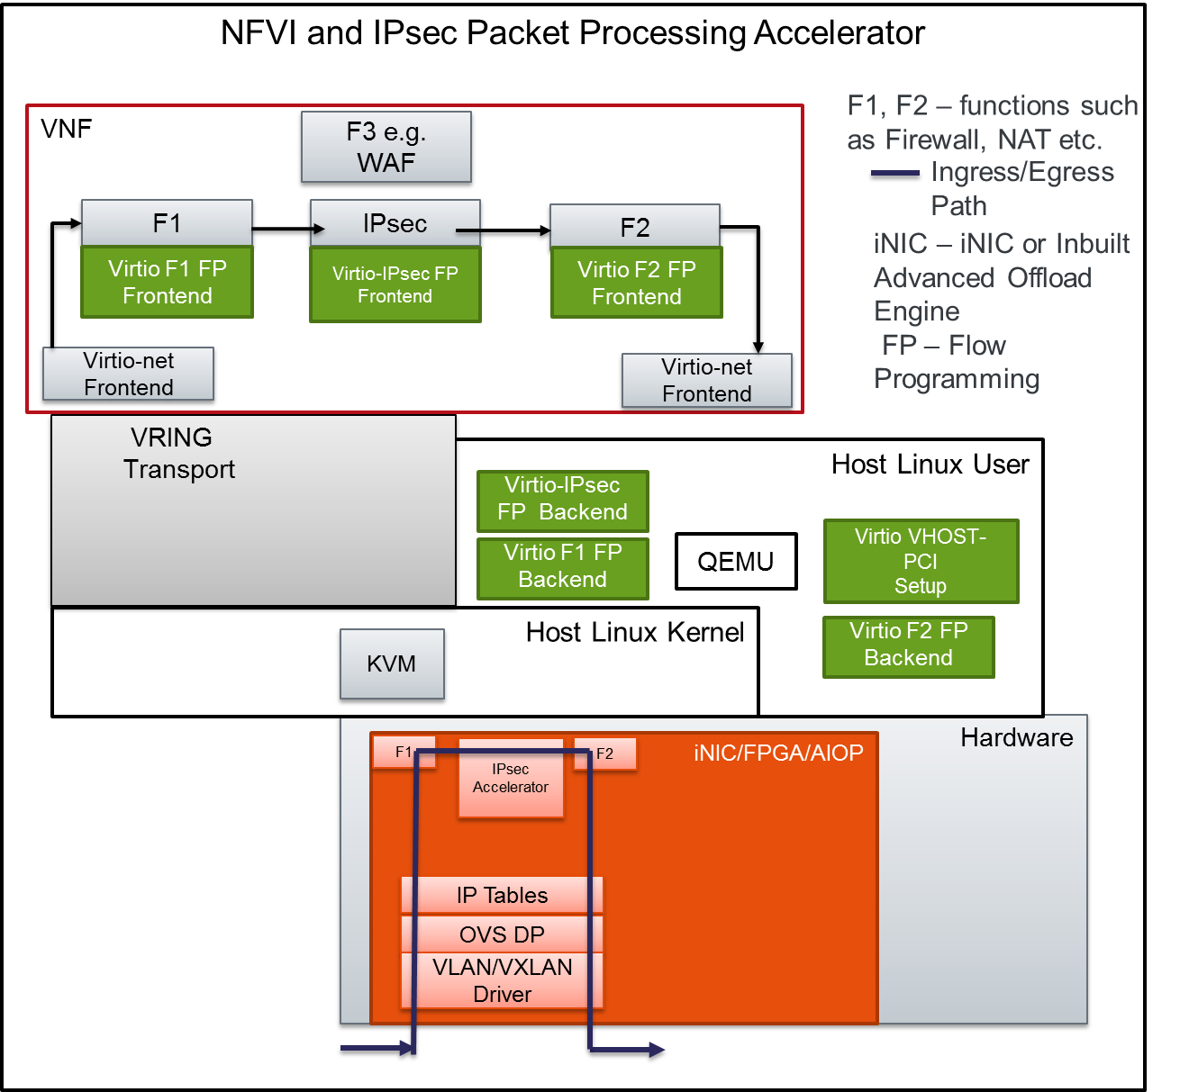
Figure 7 NFVI IPsec Packet Processing Accelerator – Offload Data Path Flow
Figure 7 shows the packet flow, where the VNF is able to set up flow programming in the iNIC to apply IPsec Processing on specific flows. As a result of this, for packets matching the programmed flows, packet processing happens in the iNIC itself.

Inline Offload – Packet flow
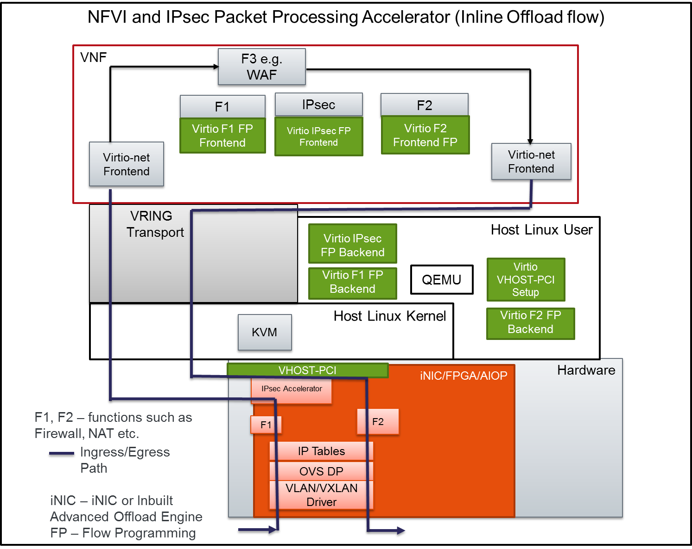
Figure 6 NFVI and IPsec Packet Processing Accelerator – WAF Flow (Inline offload)
Figure 8 shows the packet flow, in the case, where the packets have to be processed by the VNF e.g. TCP port 80 traffic. In this case, part of the packet processing happens in the iNIC as part of the offload operation, namely F1 processing and IPsec processing (Inbound processing or decryption). The packets are then sent to the VNF through the Virtio-net frontend to the F3 (WAF) for processing. Subsequent to processing by F3, the packets are sent via Virtio-net Frontend for subsequent processing (Outbound IPsec processing) and F2 before being sent out.

Performance Benefits
- NFV Accelerator Offload using hardware accelerators can reduce significant compute cycles utilization by the VNFs leaving more for other tasks of VNF and hence result in a capacity gain, throughput gain, connection rate gain or some combination of the above for the VNF.
- Avoiding Virtualization Layer interaction on a per packet basis would bring significant performance gain and, hence it is important to consider methods to bypass the Virtualization layer on a per packet basis.

Management & Orchestration Requirements
Orchestrator shall match VNF’s accelerator’s requirements with NFVI’s accelerator capabilities. Some of the requirements are:
- Compute nodes shall advertise the accelerators it has, number of virtual entities accelerator can support, performance of the accelerators.
- Compute nodes shall periodically advertise the virtual accelerators and current bandwidth of accelerators.
- VNF images indicate the type of accelerators it can take advantage of.
- Orchestrator choosing the right compute node while instantiating the vNF.
- Orchestrator informing the compute node that is chosen to bring up the vNF with information on which accelerators are to be instantiated.
- Compute node to instantiate the accelerators and attaching them to the vNF that is being brought up.

Possible Accelerators
Crypto – Public key and Symmetric Key, IPsec Protocol Accelerator, SSL Record Layer Accelerators, Pattern Matching, Compression, De-compression, PDCP Accelerator, SRTP Protocol Accelerator and Table Lookup Accelerators

Live migration Consideration
- When VNFs move from one NFVI node to another, the VNF function should continue to work with minimal disruption.

