Title: | Promise: Resource Management
from Source: | OPNFV Promise project  https://wiki.opnfv.org/promise
Editors: | Ashiq Khan (NTT DOCOMO, khan@nttdocomo.com),  Bertrand Souville (NTT DOCOMO, souville@docomolab-euro.com)
Authors: | Ravi Chunduru (Clear Path, e-mail)
 | Peter Lee (Clear Path, e-mail)
 | Gerald Kunzmann (NTT DOCOMO, kunzmann@docomolab-euro.com)
 | Ryota Mibu (NEC, r-mibu@cq.jp.nec.com)
 | Carlos Goncalves (NEC, Carlos.Goncalves@neclab.eu)
 | Arturo Martin De Nicolas (Ericsson, e-mail)
Project creation date: | 2014-12-04
Submission date: | 2015-03-XX

ABSTRACT: “Promise” is an OPNFV requirement project. Its objective is to realize ETSI NFV defined resource reservation and NFVI capacity features within the scope of OPNFV. Promise provides the details of the requirements on resource reservation, NFVI capacity management at VIM, specification of the northbound interfaces from VIM relevant to these features, and implementation plan to realize these features in OPNFV.

Definition of terms:
Different SDOs and communities use different terminology related to NFV / Cloud / SDN. This list tries to define an OPNFV terminology, mapping/translating the OPNFV terms to terminology used in other contexts.
- NFVI: Virtualization Infrastructure such as HV
- (ESTI NFV) NFVI: totality of all hardware and software components which build up the environment in which VNFs are deployed
- Virtual Resource: e.g. a Virtual Machine (VM), virtual network
- (User-/admin-side) Manager: VNFM or Orchestrator
- Controller: VIM

Table of content

Table of content 2
1 Introduction [editor: Ashiq] 3
2 Use cases and scenarios [editor: Ashiq] 3
2.1 Simple resource reservation 4
2.2 Resource reservation for future usage 4
2.3 Capacity management 4
3 High level architecture and general features [editor: Ashiq] [authors: Ashiq, Peter, Bertrand, Gerald, Ravi] 4
3.1 Architecture Overview 5
3.2 General Features 5
3.3 High level northbound interface specification [authors: Bertrand, Gerald, Ravi] 5
3.3.1 Resource Reservation 5
3.3.2 Resource Capacity Management 6
3.4 Information elements [author: Bertrand, Ashiq] 6
3.4.1 Resource Reservation Request 6
3.4.2 Resource Reservation Reply 7
4 Gap analysis in upstream projects [editor: Bertrand] [authors: Bertrand, Ravi, Ryota, Carlos] 7
4.1 OpenStack 7
4.1.1 Nova Scheduler 7
4.1.2 Blazar 7
4.2 StormForge 8
4.3 Stormify 8
5 Detailed implementation plan [editor: Ravi] [authors: Ravi, Bertrand, Peter, Carlos, Ryota] 8
5.1 Framework 8
5.2 Information elements 8
5.3 Detailed northbound interface specification 8
5.4 Blueprints 8
6 Summary and conclusion [editor: Ashiq] [authors: Arturo, Gerald, …] 9
6.1 Future plan 9
7 References and bibliography 9

Introduction [editor: Ashiq]
Resource reservation is a basic function for the operation of a virtualized telecom network. In resource reservation, VIM reserves NFVO requested resources for a certain period as requested by the NFVO. A resource reservation will have a start time which could be into the future. Therefore, the reserved resources shall be available for the NFVO requested purpose (e.g. for a VNF) at the start time for the duration asked by NFVO. Resources include all three resources in an NFVI i.e. compute, storage and network.
Besides, NFVO requires abstracted NFVI resource capacity information in order to take decisions on VNF placement and other network operation. VIM requires informing NFVI resource state information to NFVO for this purpose. Promise project aims at delivering the detailed requirements on these two features defined in ETSI NFV MAN GS [ref], potential implementation architecture and plan, and the VIM northbound interface specification for resource reservation and capacity management.
Problem description
OpenStack, a prominent candidate for the VIM, cannot reserve resources for future usage. OpenStack requires instant instantiation of Virtual Machines (VMs) in order to occupy resources intended to be reserved. Blazar can reserve compute resources for future by keeping the VMs in shelved mode. However, such reserved resources can also be used for scaling out rather than new VM instantiation. Blazar do not support network and storage resource reservation yet.
Besides, OpenStack does not provide a northbound interface through which it can notify an upper layer management entity e.g. NFVO about capacity changes in its NFVI, periodically or in an event driven way. Capacity management is a feature defined in ETSI NFV [ref MAN GS] and is required in network operation.

Features

- Resource reservation
  - Set start time and end time for allocation
  - Increase/decrease reserved resources
- Resource capacity management
  - Add/remove resource pools
  - Discovery of available resource capacity on resource providers
  - Monitoring of available resource capacity on resource providers
  - Increase/decrease available resource capacity
- VIM northbound interfaces (see GS NFV-MAN 001: Chapter 7.3.1, 7.3.2, 7.3.3)
  - Receive/Reply resource reservation requests
  - Receive/Reply resource capacity pool requests
  - Allocate reserved resources when start time arrives
  - Terminate allocated resources when end time arrives

Use cases and scenarios [editor: Ashiq]

Resource reservation is a basic feature in any virtualization-based network operation. In order to perform such resource reservation from NFVO to VIM, NFVI capacity information is also necessary at the NFVO side. Below, three use cases to show typical requirements and solutions for resource reservation for future usage and capacity management is presented..
- Simple resource reservation
- Resource reservation for future usage
- Capacity management

Simple resource reservation
Reservation is inherently for the future. Even if some reserved resources are to be consumed instantly, there is a network latency in between the issuance of a resource reservation request from the NFVO, a response from the VIM, and actual allocation of the requested resources to a VNF/VNFM. Within such latency, resource capacity in the NFVI in question could change, e.g., due to failure, allocation to a different request. Therefore, the response from a VIM to the NFVO to a resource reservation request should have a validity period which shows until when this VIM can hold the requested resources, by which time, the NFVO should proceed to allocation if it wishes to consume the reserved requested. If allocation is not performed within the validity period, the response from VIM for a particular resource reservation request becomes invalid and VIM is not liable to provide those resources to NFVO/VNFM anymore.

Resource reservation for future usage
Network operators may want to reserve extra resources for future usages. Such necessity could arise from predicted congestion in telecom nodes e.g. due to local traffic spikes for concerts, natural disasters etc. In such a case, the NFVO, while sending a resource reservation request to the VIM, shall include a start time (and an end time if necessary). The start time indicates at what time the reserved resource would be allocated to a designated consumer e.g. a VNF/VNFM. Here, the requirement is that the reserved resources are available when start time arrives. How actually these requested resources are held by the VIM for the period in between the arrival of the resource reservation request and the actual allocation is outside the scope of this project.

Capacity management
NFVO takes the first decision on in which NFVI it would instantiate a VNF. Along with NFVIs resource attributes (e.g. availability of hardware accelerators, particular CPU architectures etc.), NFVI needs to know available capacity of an NFVI in order to make an informed decision on selecting a particular NFVI. Such capacity information shall be in a coarser granularity than the respective VIM, as VIM maintains capacity information of its NFVI in fine details. Therefore, VIM requires to inform the NFVO about available capacity information regarding its NFVI at a pre-determined abstraction, either by a query-response, or in an event-based, or in a periodical way.

High level architecture and general features [editor: Ashiq] [authors: Ashiq, Peter, Bertrand, Gerald, Ravi]

Architecture Overview
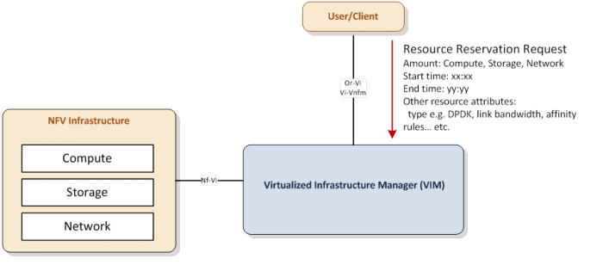
Resource Reservation for future usage scenario

General Features

High level northbound interface specification [authors: Bertrand, Gerald, Ravi]

Resource Reservation
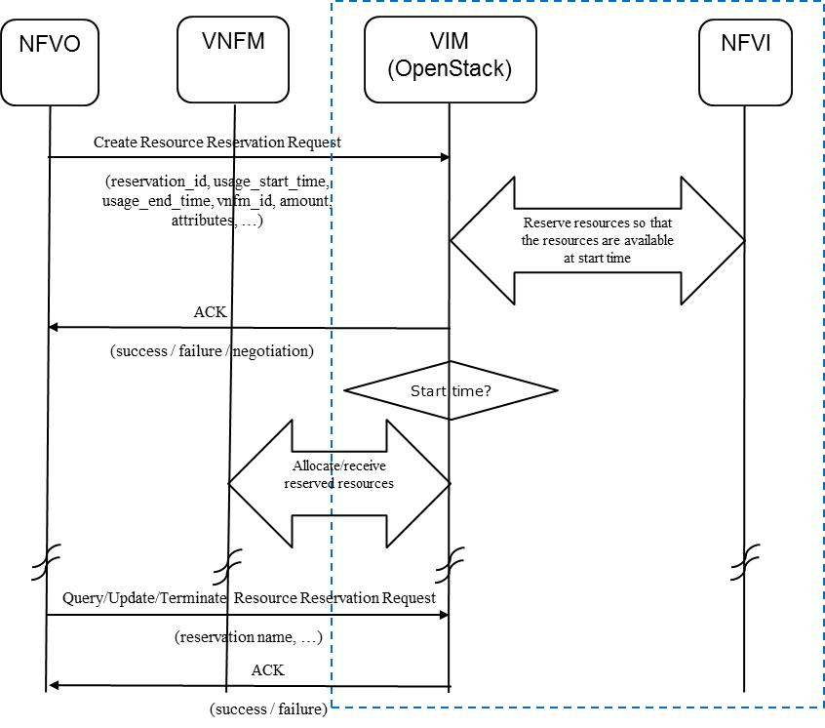

High level message flow
Placeholder for the high level specification of the resource reservation interfaces

Create Resource Reservation

Query Resource Reservation

Update Resource Reservation

Terminate Resource Reservation

Resource Capacity Management

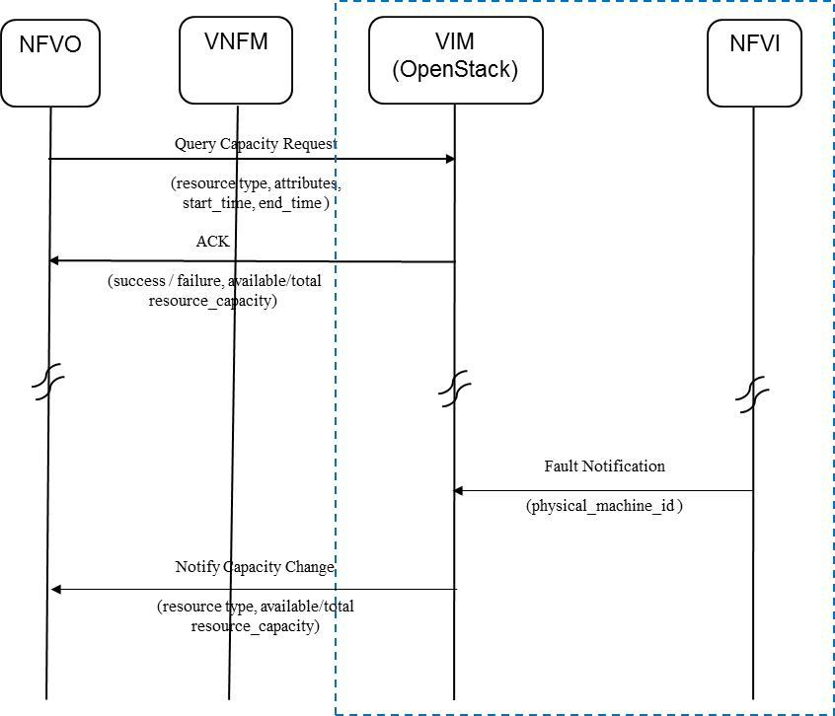

High level message flow

Placeholder for the high level specification of the resource capacity management interfaces

Query Capacity

Notify Capacity Change

Information elements [author: Bertrand, Ashiq]
Based on https://wiki.opnfv.org/_media/promise/reservation_info_elements-r0.pdf

Resource Reservation Request
Raw list of information elements:
- reservation id (issued by centralized entity e.g. OSS/NFVO)

- usage_start_time
- usage_end_time
- VNFM id
- resource attributes such as DPDK support, network link bandwidth, affinity rules, etc.
- tenant name
- flavor id
- zone id
- …

Resource Reservation Reply
Raw list of information elements:
- reserved resource data (information on the newly reserved resources e.g. VM id / reservation id (VM, VL), Connection Point id)
- error message
- …

Gap analysis in upstream projects [editor: Bertrand] [authors: Bertrand, Ravi, Ryota, Carlos]
This section provides a list of gaps in upstream projects for realizing resource reservation and management. The gap analysis work focuses on the current OpenStack release (including Blazar [2]) and StormForge [3] / Stormify [4] open source projects.

[GapAnalysis Template (Draft 0.1)]
- Category: <Which I/F or component belongs to>
- Type:<Select from the followings to identify priority>
- 'missing' (lack of functionality),
- 'deficiency in performance' (function is available, but not enough performance even in small deployment),
- 'scalability issue' (issue will be obvious in large deployments),
- Description:
- To-be: <Describe or point the requirement>
- As-is: <Describe the nearest achievement by current available features and what is missing/issue with information source, evidence and alternatives if available>
- Related blueprints <Describe related blueprints that are e.g. solving/improving (part of) the problem>

OpenStack

Nova Scheduler

Blazar

Resource reservation for future usage
- Category: Blazar
- Type: ‘missing’ (lack of functionality)
- Description:
  - To-be: To reserve a whole set of compute/storage/network resources in the future
  - As-is: Blazar currently can do only compute resource reservation by using “Shelved VM”
- Related blueprints:
  - https://blueprints.launchpad.net/blazar/+spec/basic-volume-plugin
  - https://blueprints.launchpad.net/blazar/+spec/basic-network-plugin
  - It was planned in Blazar to implement volume and network/fixed ip reservations

Resource reservation update
- Category: Blazar
- Type: ‘missing’ (lack of functionality)
- Description:
  - To-be: Have the possibility of adding/removing resources to an existing reservation, e..g in case of NFVI failure
  - As-is: Currently in Blazar, a reservation can only be modified in terms of start/end time
- Related blueprints: N/A

Give me an offer
- Category: Blazar
- Type: ‘missing’ (lack of functionality)
- Description:
  - To-be: To have the possibility of giving a quotation to a requesting user and an expiration time. Reserved resources shall be released if they are not claimed before this expiration time.
  - As-is: Blazar can already send notification e.g. to inform a given user that a reservation is about to expire
- Related blueprints: N/A

StormForge

Stormify

Detailed implementation plan [editor: Ravi] [authors: Ravi, Bertrand, Peter, Carlos, Ryota]
Based on https://clearpath.atlassian.net/wiki/display/CPNOS/StormForge+-+VIM+Extensible+Services

Framework

Information elements

Detailed northbound interface specification

Blueprints

Summary and conclusion [editor: Ashiq] [authors: Arturo, Gerald, …]

Future plan

References and bibliography

[1] OPNFV, “Doctor Project,” [Online]. Available at https://wiki.opnfv.org/doctor

[2] OpenStack Blazar Project [Online]. Available at https://wiki.openstack.org/wiki/Blazar

[3] Stormforge Project [Online] Available at https://github.com/stormstack/stormforge

[4] Stormify Project [Online] Available at https://github.com/stormstack/stormify

[5] ETSI NFV GS MAN 001

